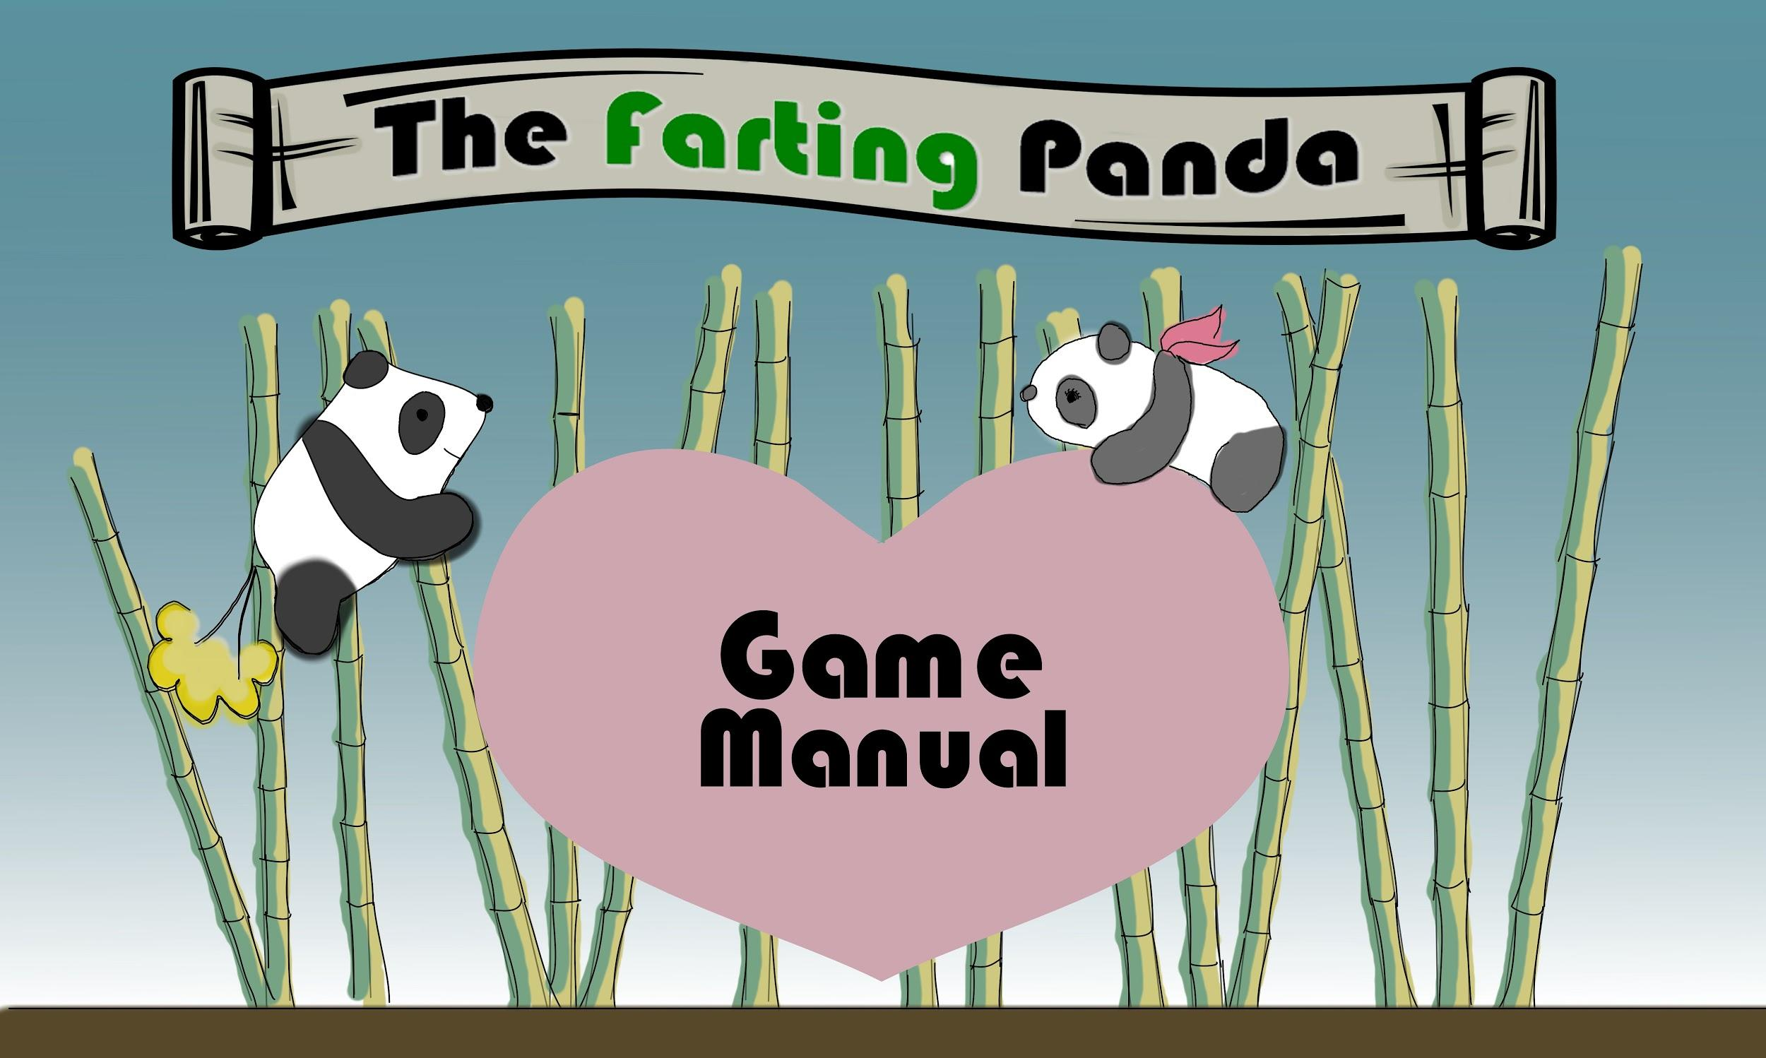

**TABLE OF CONTENTS**

I. Getting Started \_\_\_\_\_\_\_\_\_\_\_\_\_\_\_\_\_\_\_\_\_\_\_\_\_\_\_\_\_\_\_\_\_\_\_\_\_\_\_\_\_ 2

a. Foreword \_\_\_\_\_\_\_\_\_\_\_\_\_\_\_\_\_\_\_\_\_\_\_\_\_\_\_\_\_\_\_\_\_\_\_\_\_\_\_\_\_\_\_\_\_ 2

b. Background Story \_\_\_\_\_\_\_\_\_\_\_\_\_\_\_\_\_\_\_\_\_\_\_\_\_\_\_\_\_\_\_\_\_\_\_\_\_ 2

II. Installing the Game \_\_\_\_\_\_\_\_\_\_\_\_\_\_\_\_\_\_\_\_\_\_\_\_\_\_\_\_\_\_\_\_\_\_\_\_\_ 3

a. Instruction \_\_\_\_\_\_\_\_\_\_\_\_\_\_\_\_\_\_\_\_\_\_\_\_\_\_\_\_\_\_\_\_\_\_\_\_\_\_\_\_\_\_ 3

b. System Requirement \_\_\_\_\_\_\_\_\_\_\_\_\_\_\_\_\_\_\_\_\_\_\_\_\_\_\_\_\_\_\_\_\_\_\_ 3

III. Starting the Game \_\_\_\_\_\_\_\_\_\_\_\_\_\_\_\_\_\_\_\_\_\_\_\_\_\_\_\_\_\_\_\_\_\_\_\_\_\_\_ 4

a. Start Screen \_\_\_\_\_\_\_\_\_\_\_\_\_\_\_\_\_\_\_\_\_\_\_\_\_\_\_\_\_\_\_\_\_\_\_\_\_\_\_\_\_ 4

IV. Playing the Game \_\_\_\_\_\_\_\_\_\_\_\_\_\_\_\_\_\_\_\_\_\_\_\_\_\_\_\_\_\_\_\_\_\_\_\_\_\_\_\_\_ 5

a. Controls \_\_\_\_\_\_\_\_\_\_\_\_\_\_\_\_\_\_\_\_\_\_\_\_\_\_\_\_\_\_\_\_\_\_\_\_\_\_\_\_\_\_\_\_\_ 5

b. User Interfaces \_\_\_\_\_\_\_\_\_\_\_\_\_\_\_\_\_\_\_\_\_\_\_\_\_\_\_\_\_\_\_\_\_\_\_\_\_\_ 5

c. Consumables \_\_\_\_\_\_\_\_\_\_\_\_\_\_\_\_\_\_\_\_\_\_\_\_\_\_\_\_\_\_\_\_\_\_\_\_\_\_\_\_\_\_ 6

d. Enemies \_\_\_\_\_\_\_\_\_\_\_\_\_\_\_\_\_\_\_\_\_\_\_\_\_\_\_\_\_\_\_\_\_\_\_\_\_\_\_\_\_\_\_\_\_\_ 6

e. Objectives and Check Points \_\_\_\_\_\_\_\_\_\_\_\_\_\_\_\_\_\_\_\_\_\_\_\_\_\_ 6

V. Game Credits \_\_\_\_\_\_\_\_\_\_\_\_\_\_\_\_\_\_\_\_\_\_\_\_\_\_\_\_\_\_\_\_\_\_\_\_\_\_\_\_\_\_\_\_\_\_ 8

**I. Getting Started**

**a. Foreword**

The Farting Panda is a quarter project for a Game Development class in Cal Poly Pomona. It is a 2D platformer game developed by a team of five CS470 students in Spring quarter 2017. The goal of this game is to demonstrate understanding of video game development.

**b. Background Story**

Mating season in Bambooland has just begun, a panda with serious digestive issues sets out to find his ultimate soulmate. Standing between them are treacherous natural terrains and the vicious panda hunters. Can the brave farting panda overcome his adversaries and answer his true love’s mating call before the mating season ends?

**II. Installing the Game**

**a. Instruction**

Unzip the TFPv1.zip files to any directory. Click on TFP.exe to commence the game.

**b. System Requirement**

For Desktop Computers:

OS: Windows XP SP2+, Mac OS X 10.8+, Ubuntu 12.04+, SteamOS+.

Graphics card: DX9 (shader model 3.0) or DX11 with feature level 9.3 capabilities.

CPU: SSE2 instruction set support.

**III. Starting the Game**

**a. Start Screen**

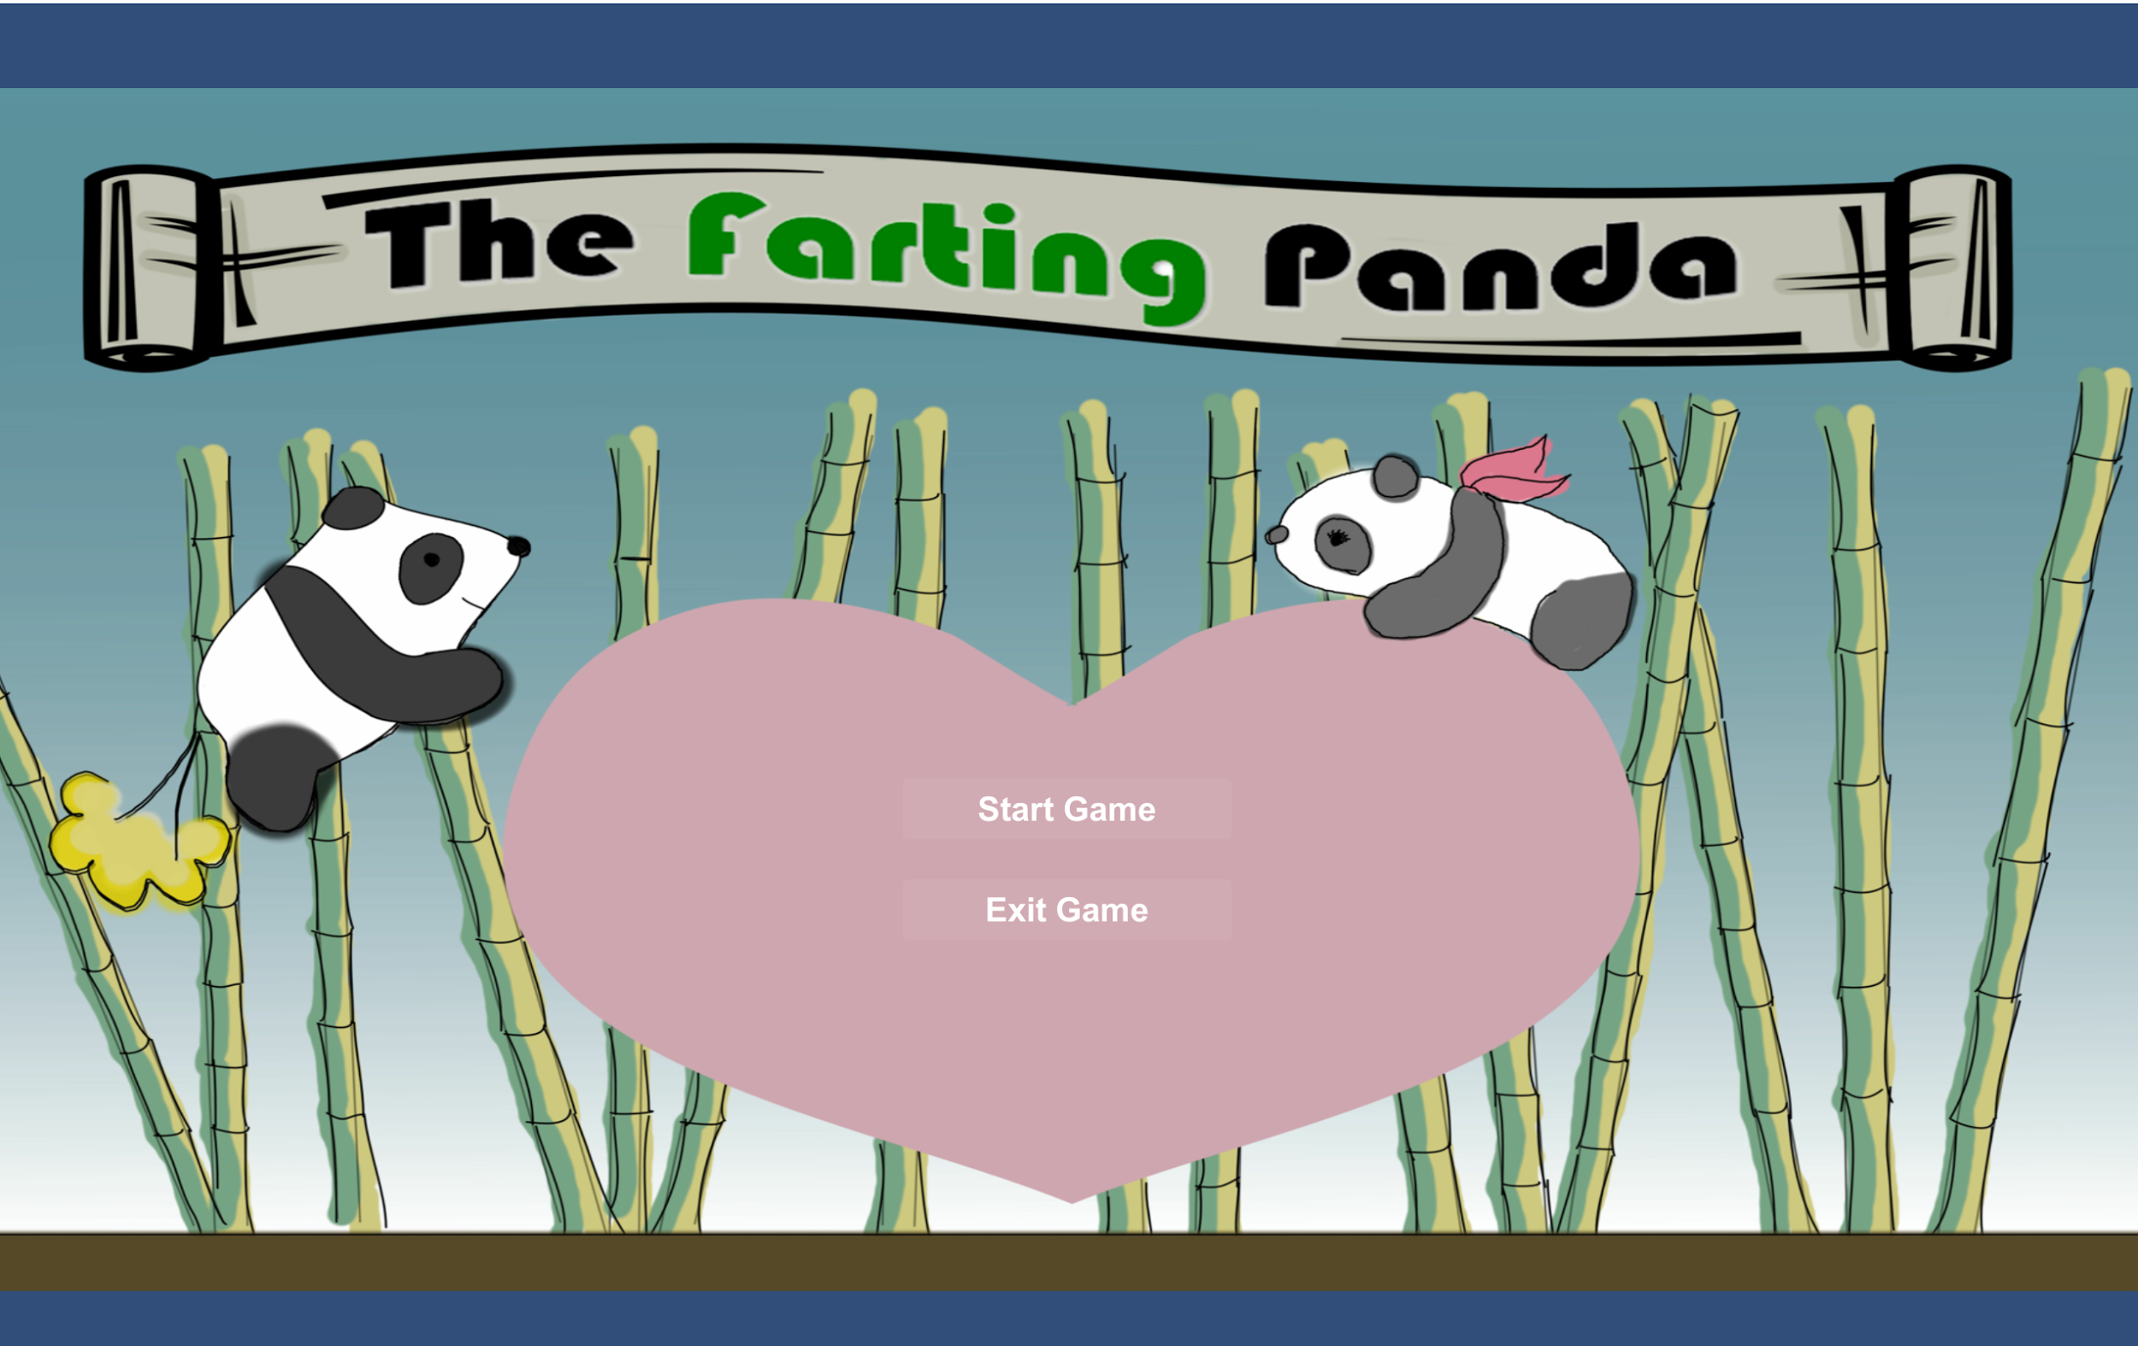

Start Game - To start the game

Exit Game - To exit the game

**IV. Playing the Game**

**a. Controls**

A - Move/Face leftward

D - Move/Face rightward

W - Horizontal Fart

S - Upward Fart

Space - Jump

Shift - Big fart in place

P - Pause game

**b. User Interfaces**

Hp Gauge:

Hp Gauge.PNG

Displays Panda’s current HP.

Fart Gauge:

Fart Gauge.PNG

Displays Panda’s current Fart capacity. Beware- if you have too much gas, you may not be able to keep it in.

Score:

Displays the current score.

Timer:

Displays the elapsed time since the beginning of the current level.

Pause Menu:

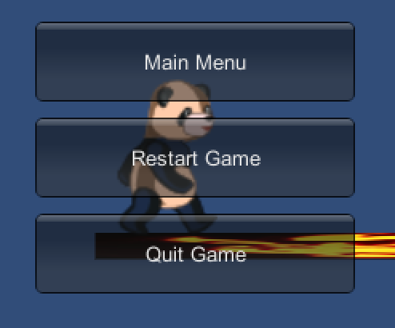

Main Menu - to go back to start screen

Restart Game - to restart the current level

Quit Game - to exit the game

**c. Consumables**

Heart:



Heals Panda’s HP by 1.

Bamboo:



Regenerates Panda’s Fart capacity by 10 (the panda has a fast metabolism).

**d. Enemies**

Hunter:



This merciless panda hunter shoots projectiles at the panda and will not stop until the panda is dead (or they get bored). Strangly, concentrated methane seems to corrode their circuits. Fortunately, our panda friend happens to have plenty of that.

Trap:



Crude and highly illegal bear trap. Deals heavy damage to any animal unfortunate enough to be caught in it.

**e. Objectives and Checkpoints**

CheckPoints:



Activates when the panda walks pass the checkpoint object, it serves as the panda’s respawn point.

Pink Panda:

pink_static.png

The game ends when the panda meets the pink panda.

**V. Game Credits**

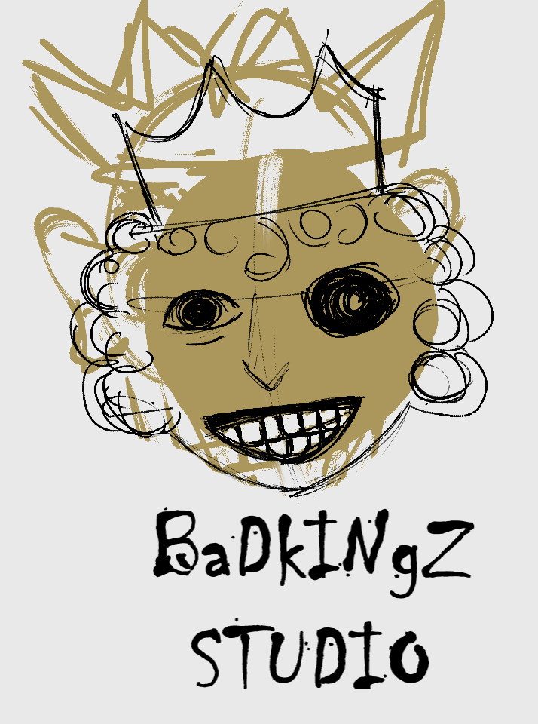

**Project Manager:** Mahmudur Khan

**Programming:** Nathaniel Krueper, Benjamin Krueper

**Design:** Nathaniel Krueper, Benjamin Krueper

**Art:**  Mahmudur Khan

**Sound:** Ian Stodart

**Quality Assurance:** Chu Yiu Cheung, Ian Stodart

**Business Analyst:** Chu Yiu Cheung